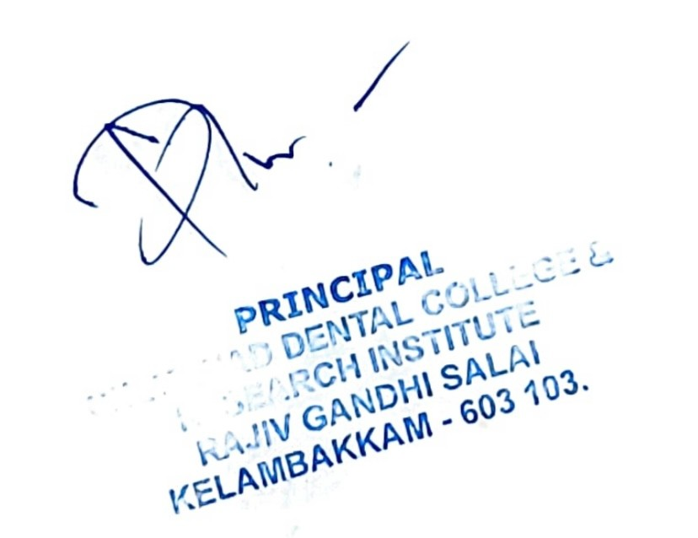

QUANTUM OF FINANCIAL CONTRIBUTION -2023-24

|  |  |  |
| --- | --- | --- |
| **YEAR** | **NO OF ENROLLED ALUMNI** | **ALUMNI CONTRIBUTION IN RUPEES** |
| 2022 -23 | 82+13 | **Rs. 1000** |
| **TOTAL** | **95** | **Rs. 95000** |

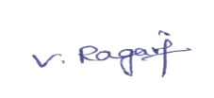 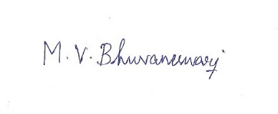

Secretary Treasurer

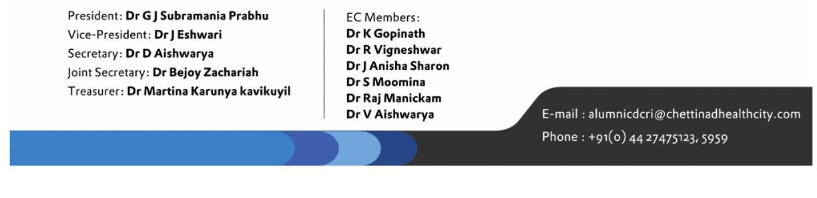

|  |  |  |
| --- | --- | --- |
| S.NO | ALUMNI NAME | FINANCIAL CONTRIBUTION IN RUPEES |
| 1 | Raajesh A K R | Rs. 1000 |
| 2 | Mathanarajan | Rs. 1000 |
| 3 | Aadhya | Rs. 1000 |
| 4 | Aatheef Ahmed | Rs. 1000 |
| 5 | Abigna Reddy | Rs. 1000 |
| 6 | Abirami | Rs. 1000 |
| 7 | Afridh Hameedha | Rs. 1000 |
| 8 | Aishwarya G | Rs. 1000 |
| 9 | Akshaya B | Rs. 1000 |
| 10 | Akshaya S | Rs. 1000 |
| 11 | Amira Moosa | Rs. 1000 |
| 12 | Anuchandhini | Rs. 1000 |
| 13 | Anudharshini | Rs. 1000 |
| 14 | Anusha naidu | Rs. 1000 |
| 15 | Ashrita | Rs. 1000 |
| 16 | Barath Kumar | Rs. 1000 |
| 17 | Bavadharini | Rs. 1000 |
| 18 | Bency Joseph Raj | Rs. 1000 |
| 19 | Buvaneshwari | Rs. 1000 |
| 20 | Chithaluru Pranathi | Rs. 1000 |
| 21 | Deepthika | Rs. 1000 |
| 22 | Dharshini | Rs. 1000 |
| 23 | Dhiviya N | Rs. 1000 |
| 24 | Dhwarkamai | Rs. 1000 |
| 25 | Divyabharathi | Rs. 1000 |
| 26 | Divyadarshini | Rs. 1000 |

|  |  |  |
| --- | --- | --- |
| 27 | Gayathri N | Rs. 1000 |
| 28 | Gayathri S A | Rs. 1000 |
| 29 | Gogulakrishnan | Rs. 1000 |
| 30 | Gokul S | Rs. 1000 |
| 31 | Haripriya | Rs. 1000 |
| 32 | Ishwerya M | Rs. 1000 |
| 33 | Iswariya S | Rs. 1000 |
| 34 | Jayavarsha A S | Rs. 1000 |
| 35 | Joselin Rosary | Rs. 1000 |
| 36 | Kaavya B | Rs. 1000 |
| 37 | Kamalisha | Rs. 1000 |
| 38 | Kanishka Nandhini | Rs. 1000 |
| 39 | Kaviya S | Rs. 1000 |
| 40 | Kavya Priyadharshini | Rs. 1000 |
| 41 | Kowsalya | Rs. 1000 |
| 42 | Lakshana | Rs. 1000 |
| 43 | Laurel Vijitha | Rs. 1000 |
| 44 | Logeshwari | Rs. 1000 |
| 45 | Mahamudha | Rs. 1000 |
| 46 | Maheshwaran | Rs. 1000 |
| 47 | Mothirajathi | Rs. 1000 |
| 48 | Mukilan | Rs. 1000 |
| 49 | Nandhini | Rs. 1000 |
| 50 | Narendhar | Rs. 1000 |
| 51 | Nithyasri | Rs. 1000 |
| 52 | Nivedhitha | Rs. 1000 |
| 53 | Pavithra G | Rs. 1000 |
| 54 | Pavithra M | Rs. 1000 |
| 55 | Prathosh | Rs. 1000 |
| 56 | Priyadharshini Ganesan | Rs. 1000 |
| 57 | Priyadharshini A | Rs. 1000 |

|  |  |  |
| --- | --- | --- |
| 58 | Raksha R | Rs. 1000 |
| 59 | Rohith Chandru | Rs. 1000 |
| 60 | Sahana shree | Rs. 1000 |
| 61 | Sakthi Mani murugan | Rs. 1000 |
| 62 | Santhini | Rs. 1000 |
| 63 | Savitha | Rs. 1000 |
| 64 | Sirpika | Rs. 1000 |
| 65 | Sneha | Rs. 1000 |
| 66 | Sonasri | Rs. 1000 |
| 67 | Soofiya Snober | Rs. 1000 |
| 68 | Srinidhi | Rs. 1000 |
| 69 | Srinivasa Ragavan | Rs. 1000 |
| 70 | Sriram Mahesh | Rs. 1000 |
| 71 | Srividhya | Rs. 1000 |
| 72 | Srivishnu | Rs. 1000 |
| 73 | Subhathi | Rs. 1000 |
| 74 | Supriya Srilakshmi | Rs. 1000 |
| 75 | Suvetha Manoharan | Rs. 1000 |
| 76 | Swathi | Rs. 1000 |
| 77 | Swetha nidhi | Rs. 1000 |
| 78 | Vaishali | Rs. 1000 |
| 79 | Vaishnavi | Rs. 1000 |
| 80 | Vigknesh S | Rs. 1000 |
| 81 | Vignesh M K | Rs. 1000 |
| 82 | Vinitha | Rs. 1000 |

EXAM APPEARED FEBRURARY 2022 -PASSED OUT FEBRUARY 2023

|  |  |  |
| --- | --- | --- |
| 1 | Raveena. R | Rs. 1000 |
| 2 | Mathanarajan. A | Rs. 1000 |
| 3 | Ragavi V | Rs. 1000 |
| 4 | Thouseef Ahmed M | Rs. 1000 |
| 5 | Sowmya A | Rs. 1000 |
| 6 | Vishnu Kumar | Rs. 1000 |
| 7 | Priyanka V | Rs. 1000 |
| 8 | Ramasamy Narayanan R | Rs. 1000 |
| 9 | Prackadeesh | Rs. 1000 |
| 10 | Harini Prabha | Rs. 1000 |
| 11 | Dhanesh Bala KR | Rs. 1000 |
| 12 | Shreedevi | Rs. 1000 |
| 13 | Pavithra G | Rs. 1000 |

